SOFTWARE ENGINEERING REQUIREMENT
A software requirements specification (SRS) is a description of a software system to be developed. It lays out functional and non-functional requirements, and may include a set of use cases that describe user interactions that the software must provide.
What are software requirements specification (SRS)? Software requirements specification capture system behavior as opposed to non-functional requirements specifications which define attributes as not behavior. This 'functionality' refers to services, tasks or functions the user performs using the system in question.
FUNCTIONAL AND NON FUNCTIONAL REQUIREMENT
If there is any one thing any project must have in order not to be doomed to failure, that is a sensible and comprehensive collection of both the functional and non-functional requirements.
Any project’s requirements need to be well thought out, balanced and clearly understood by all involved, but perhaps of most importance is that they are not dropped or compromised halfway through the project.
he official definition of ‘a functional requirement’ is that it essentially specifies something the system should do.
Typically, functional requirements will specify a behaviour or function, for example:
“Display the name, total size, available space and format of a flash drive connected to the USB port.” Other examples are “add customer” and “print invoice”. for instance, a functional requirement for a milk carton would be “ability to contain fluid without leaking”
some of the more typical functional requirements include:
Business Rules, Transaction corrections, adjustments and cancellations, Administrative functions
Authentication, Authorization levels, Audit Tracking, External Interfaces, Certification Requirements, Reporting Requirements, Historical Data, Legal or Regulatory Requirements.
The definition for a non-functional requirement is that it essentially specifies how the system should behave and that it is a constraint upon the systems behaviour. One could also think of non-functional requirements as quality attributes for of a system.
Non-functional requirements cover all the remaining requirements which are not covered by the functional requirements. They specify criteria that judge the operation of a system, rather than specific behaviours, for example: “Modified data in a database should be updated for all users accessing it within 2 seconds.”
Some typical non-functional requirements are:
Performance – for example Response Time, Throughput, Utilization, Static Volumetric, Scalability, Capacity, Availability, Reliability, Recoverability, Maintainability, Serviceability, Security, Regulatory, Manageability, Environmental, Data Integrity, Usability, Interoperability.
As said above, non-functional requirements specify the system’s ‘quality characteristics’ or ‘quality attributes’.
Many different stakeholders have a vested interest in getting the non-functional requirements right particularly in the case of large systems where the buyer of the system is not necessarily also the user of the system.
The importance of non-functional requirements is therefore not to be trifled with. One way of ensuring that as few as possible non-functional requirements are left out is to use non-functional requirement groups.

REQUIREMENT SPECIFICATION
A software requirements specification (SRS) is a document that captures complete description about how the system is expected to perform. It is usually signed off at the end of requirements engineering phase.
Software requirements specification establishes the basis for an agreement between customers and contractors or suppliers (in market-driven projects, these roles may be played by the marketing and development divisions) on what the software product is to do as well as what it is not expected to do. Software requirements specification permits a rigorous assessment of requirements before design can begin and reduces later redesign. It should also provide a realistic basis for estimating product costs, risks, and schedules. Software requirements specification prevents software projects from failure.
Requirements engineering (RE) refers to the process of defining, documenting and maintaining requirements to the sub-fields of systems engineering and software engineering concerned with this process.
One limited study in Germany presented possible problems in implementing requirements engineering and asked respondents whether they agreed that they were actual problems. The results were not presented as being generalizable but suggested that the principal perceived problems were incomplete requirements, moving targets, and time boxing, with lesser problems being communications flaws, lack of traceability, terminological problems, and unclear responsibilities.
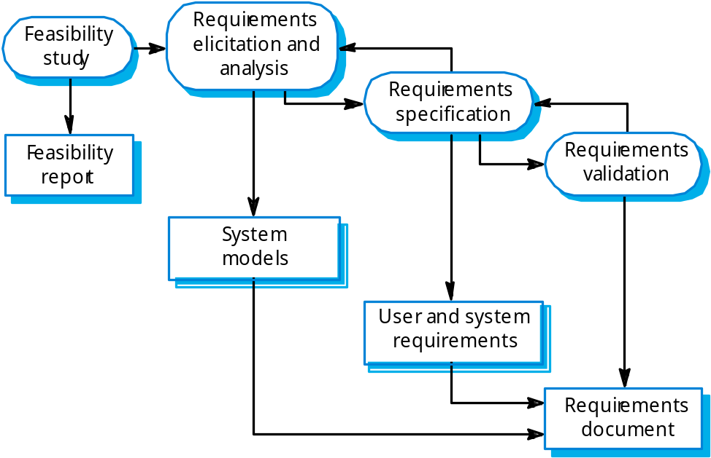
The overall requirements engineering process includes four high-level requirements engineering sub-process:
1. Feasibility studies.
2. Requirements elicitation and analysis.
3. Requirements validation.
4. Requirements management.

FEASIBILITY STUDIES
A feasibility study decides whether or not the proposed system is worthwhile.A short focused study that checks
1. If the system contributes to organizational objectives;
2. If the system can be engineered using current technology and within budget;
3. If the system can be integrated with other systems that are already used.

REQUIREMENTS ELICITATION AND ANALYSIS
Sometimes called requirements elicitation or requirements discovery. Involves technical staff working with customers to find out about the application domain, the services that the system should provide and the system’s operational constraints.
May involve end-users, managers, engineers involved in maintenance, domain experts, trade unions, etc. These are called stakeholders.

REQUIREMENTS VALIDATION
Concerned with demonstrating that the requirements define the system that the customer really wants.
Requirements validation covers a part of analysis in that it is concerned with finding problems with requirements.
Requirements error costs are high so validation is very important
Fixing a requirements error after delivery may cost up to 100 times the cost of fixing an implementation error.
In fact, a change to the requirements usually means that the system design and the implementation must also be changed and the testing has to be performed again.

REQUIREMENTS VALIDATION TECHNIQUES
The following techniques can be used individually or in conjunction.
Requirements reviews
Systematic manual analysis of the requirements performed by a team of reviewers (see next slides).
Prototyping
Using an executable model of the system to check requirements. Covered in Chapter 17.
Test-case generation
Developing tests for requirements to check testability.
If the test is difficult to design, usually the related requirements are difficult to implement.

REQUIREMENTS MANAGEMENT
The requirements for large systems are frequently changing.
In fact, during the software process, the stakeholders’ understanding of the problem is constantly changing.
Requirements management is the process of managing changing requirements during the requirements engineering process and system development.
Requirements are inevitably incomplete and inconsistent
New requirements emerge during the process as business needs change and a better understanding of the system is developed;
Different viewpoints have different requirements and these are often contradictory.
It is hard for the users and customers to anticipate what effects the new system will have on the organization.
Often, only when the system has been deployed, new requirements inevitably emerge.
This is mainly due to the fact that, when the end-users have experience of the new system, they discover new needs and priority.

REFRENCES
- Bourque, P.; Fairley, R.E. (2014). "Guide to the Software Engineering Body of Knowledge (SWEBOK)". IEEE Computer Society. Retrieved 17 July 2014.
- "Software requirements specification helps to protect IT projects from failure". Retrieved 10 August 2016.
- Pressman, Roger (2010). Software Engineering: A Practitioner's Approach. Boston: McGraw Hill. p. 123. ISBN 9780073375977.
- "DI-IPSC-81433A, DATA ITEM DESCRIPTION SOFTWARE REQUIREMENTS SPECIFICATION (SRS)". everyspec.com. 1999-12-15. Retrieved 2013-04-04.
- Stellman, Andrew & Greene, Jennifer (2005). Applied software project management. O'Reilly Media, Inc. p. 308. ISBN 0596009488.
- http://www.gatherspace.com/static/software_requirement_specification.htm

